- The Office for Budget Responsibility's spring forecast update always looked like a box-ticking exercise. The events since the weekend reinforced that view – the surge in oil and gas prices means GDP growth is likely to be weaker, and inflation higher, than the OBR forecasts this year.
- Although the OBR took on board the recent lower inward migration data and cut its medium-term forecast, its assumptions still look too high. We expect it will have to cut its growth forecasts and raise its borrowing projections over time.
Chancellor of the Exchequer Rachel Reeves has vowed to hold only one fiscal event per year, and, unlike 2025, she remains on track to keep that promise. Her statement today contained no new fiscal announcements and merely picked out the highlights from the OBR's new forecast.
The US-Iran conflict rendered the OBR's short-term forecast out of date before it was published. Its new forecast for GDP growth is slightly higher than our pre-conflict projection, and its inflation forecast is lower. We'll publish a new baseline forecast on March 10, and this will assume much higher oil and gas prices in the near term. This will lead us to cut our growth forecast and raise our projection for inflation.
We'd previously flagged the potential for lower inward migration to force the OBR to cut its medium-term growth forecast. The official forecaster made its first step in that direction today, cutting its projections for net inflows by an average of 60,000 a year from 2026-2031. But we think its assumptions still look too high and expect that the OBR will be forced to lower its profile further (Chart 1). This would damage growth prospects and imply a weaker outlook for the public finances.
More broadly, we remain sceptical that the fiscal plans will deliver the reduction in borrowing that the OBR anticipates. History suggests revenue-based consolidations have a high failure rate. Relying on large increases in smaller revenue streams incentivises behavioural change. And we doubt the government will tighten policy in an election year, as current plans indicate. So, while the OBR's new forecast suggests there's reasonable headroom (£24bn or 0.7% of GDP), we think the UK fiscal situation is more parlous.
Chart 1: The OBR's new assumptions for net inward migration still look too high
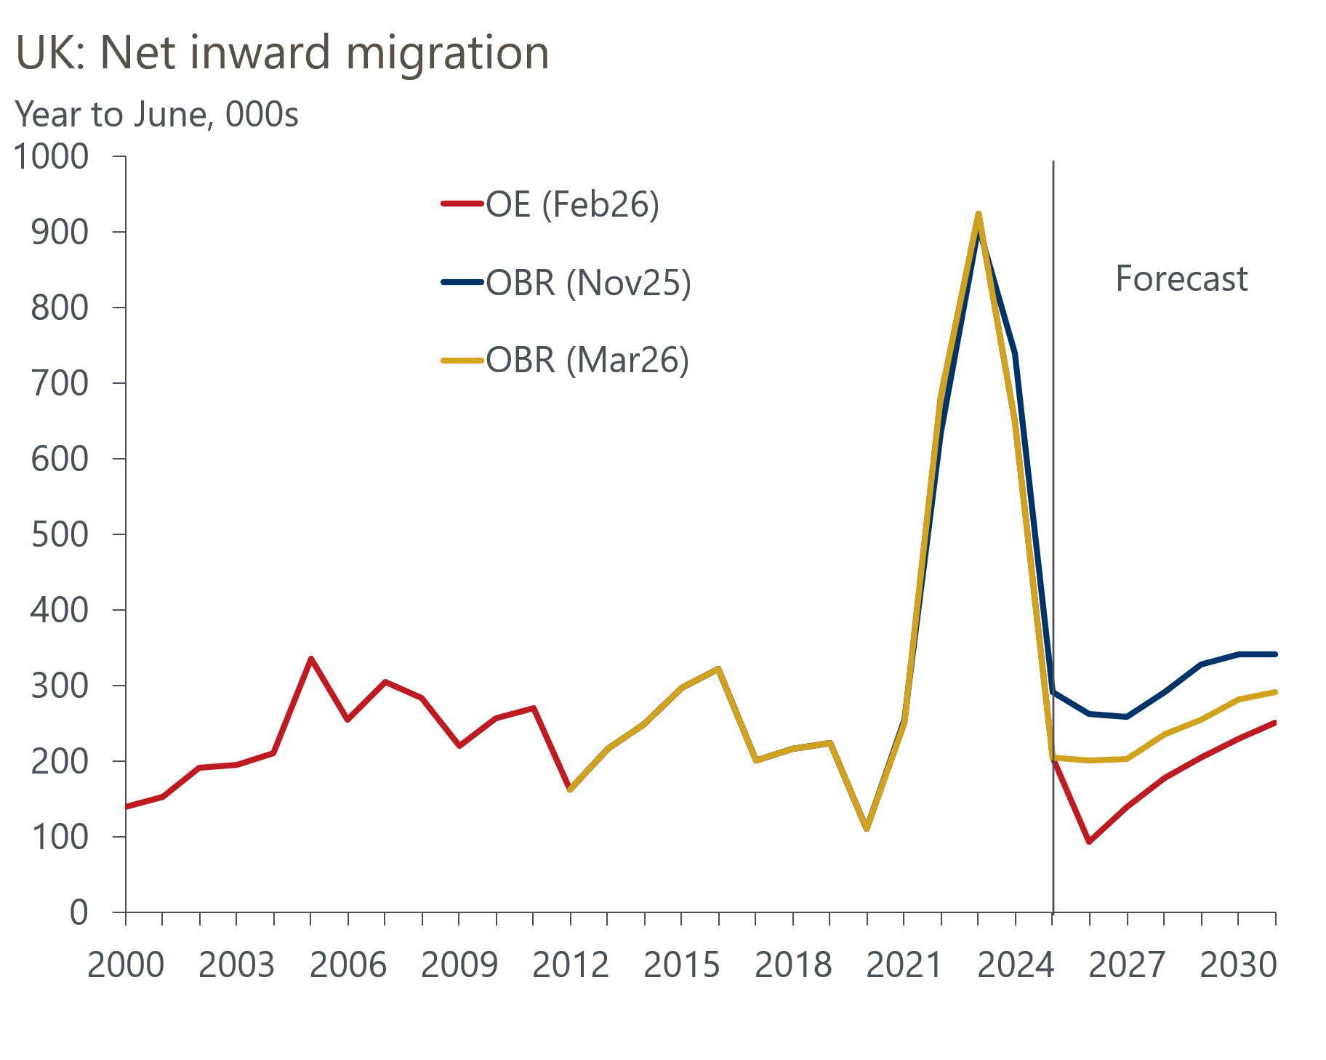
Sources: Oxford Economics, ONS

